Field-Specific Terminology

What is Field-Specific Terminology
# Source: AI Source: Provided by: [Data Path: Persons Table -> ID Column: 1, Name_En Column: Motasem Essam] -> From: [Chatgpt (GPT-4-turbo)] on [7/31/2025]
Field-Specific Terminology refers to vocabulary that is unique to a particular subject area or profession. These terms are typically not widely understood outside the field and often carry precise meanings within their context.

✅ Key Features:
# Source: AI Source: Provided by: [Data Path: Persons Table -> ID Column: 1, Name_En Column: Motasem Essam] -> From: [Chatgpt (GPT-4-turbo)] on [7/31/2025]
- Specialized to one domain (e.g., medicine, law, engineering, linguistics).
- Often not used or used differently in everyday language.
- Can include jargon, abbreviations, and acronyms specific to the field.
- May require subject knowledge to understand fully.

📚 Examples:
# Source: AI Source: Provided by: [Data Path: Persons Table -> ID Column: 1, Name_En Column: Motasem Essam] -> From: [Chatgpt (GPT-4-turbo)] on [7/31/2025]
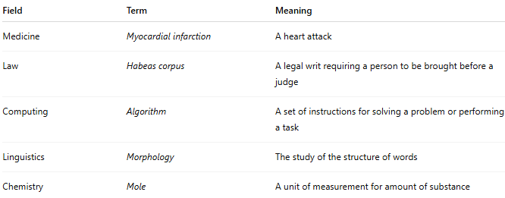
Field | Term | Meaning
Medicine | Myocardial infarction | A heart attack
Law | Habeas corpus | A legal writ requiring a person to be brought before a judge
Computing | Algorithm | A set of instructions for solving a problem or performing a task
Linguistics | Morphology | The study of the structure of words
Chemistry | Mole | A unit of measurement for amount of substance

👥 Users:
# Source: AI Source: Provided by: [Data Path: Persons Table -> ID Column: 1, Name_En Column: Motasem Essam] -> From: [Chatgpt (GPT-4-turbo)] on [7/31/2025]
- Professionals
- Subject-matter experts
- Advanced students or researchers in the field

